Ideation Phase
Brainstorm & Idea Prioritization Template

Date | 01 February 2026
Team ID | LTVIP2026TMIDS87719
Project Name | Heart Disease Analysis Using Tableau
Maximum Marks | 4 Marks

Brainstorm & Idea Prioritization:
The Heart Disease Analysis using SQL and Tableau project focuses on analyzing cardiovascular health data to identify patterns, risk factors, and trends associated with heart disease. The project utilizes MySQL for structured data storage, SQL for data processing, Tableau for interactive dashboard visualization, and Flask for web integration and deployment.
The objective of this project is to transform raw healthcare data into meaningful visual insights. By analyzing patient demographics, lifestyle habits, and medical indicators such as BMI, diabetes, smoking, physical activity, and general health condition, the project enables healthcare professionals and individuals to understand risk patterns effectively.
Through interactive dashboards and story-based visualization, the system simplifies complex medical datasets and supports preventive healthcare decision-making.
Step-1: Team Gathering, Collaboration and Select the Problem Statement

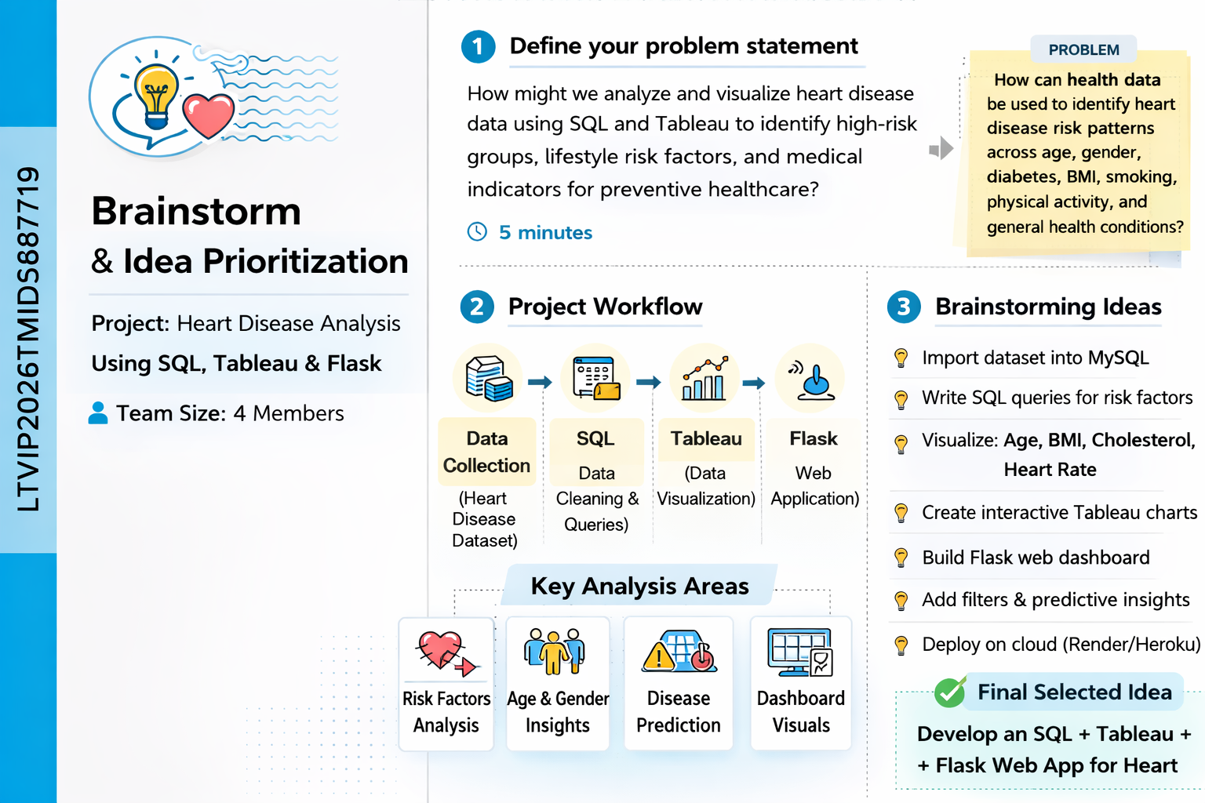
The team conducted collaborative discussions to understand the problem domain of cardiovascular diseases and the challenges associated with analyzing large-scale health data. After evaluating multiple healthcare-related analytics problems, the team finalized the following problem statement:
“To analyze heart disease data using Tableau in order to identify key demographic and lifestyle risk factors, visualize disease trends, and support preventive healthcare decision-making.”
This problem statement aligns with real-world healthcare needs and leverages data visualization for impactful insights.

Step-2: Brainstorm, Idea Listing and Grouping
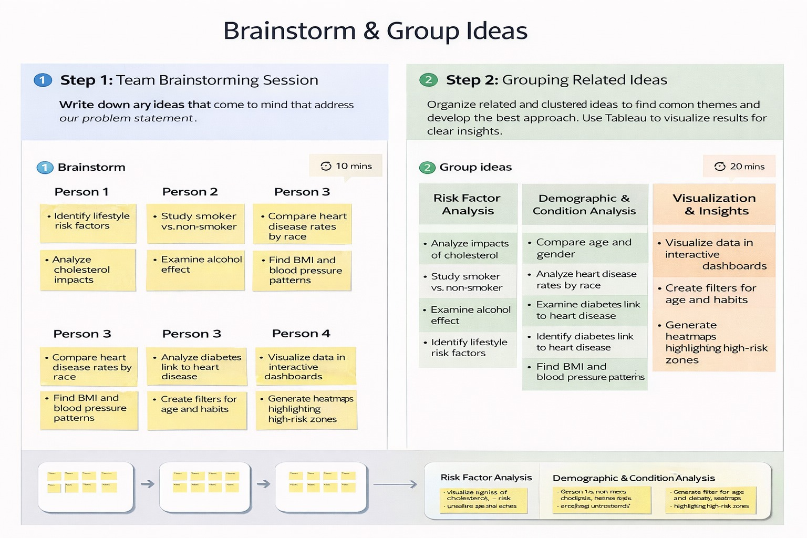

During this phase, the team generated multiple ideas related to heart disease analytics, including:
Analyzing age and gender distribution of heart disease cases.
Studying the impact of lifestyle factors such as smoking, alcohol consumption, and physical activity.
Comparing heart disease prevalence across different races and health conditions
Exploring correlations between diabetes, stroke, BMI, and heart disease esigning interactive dashboards for doctors, policymakers, and individuals
These ideas were grouped into key themes such as Demographics, Lifestyle Factors, Health Conditions, and Preventive Insights to maintain clarity and structure.

Step-3: Idea Prioritization
- The listed ideas were evaluated based on:
- Relevance to heart disease prevention
- Availability of data
- Visualization potential in Tableau
- Real-world applicability
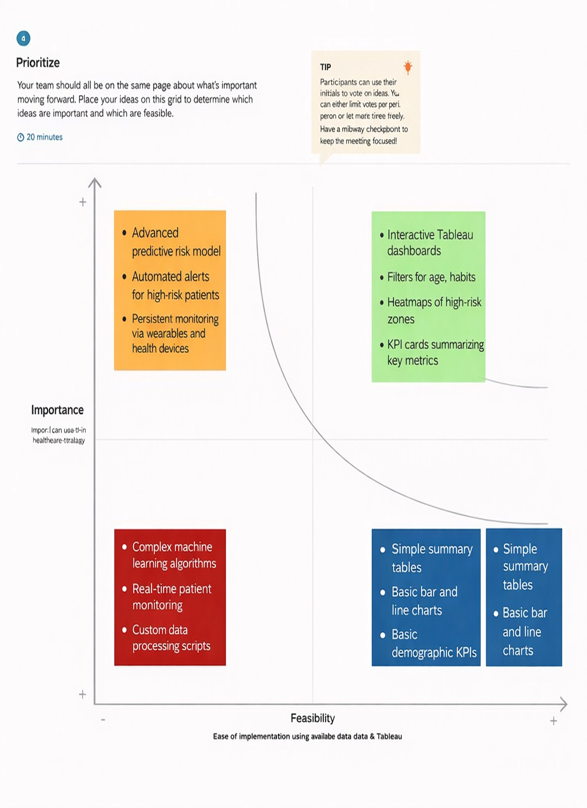
Based on this prioritization, the team decided to focus on creating multiple interactive Tableau visualizations and dashboards highlighting demographic trends, lifestyle impacts, and disease correlations to support informed healthcare decisions.

